Name: Mubashira khan
ID: F2024266207

Automated Guest Access & Captive Portal Subsystem:

Frontend Guest Authentication:

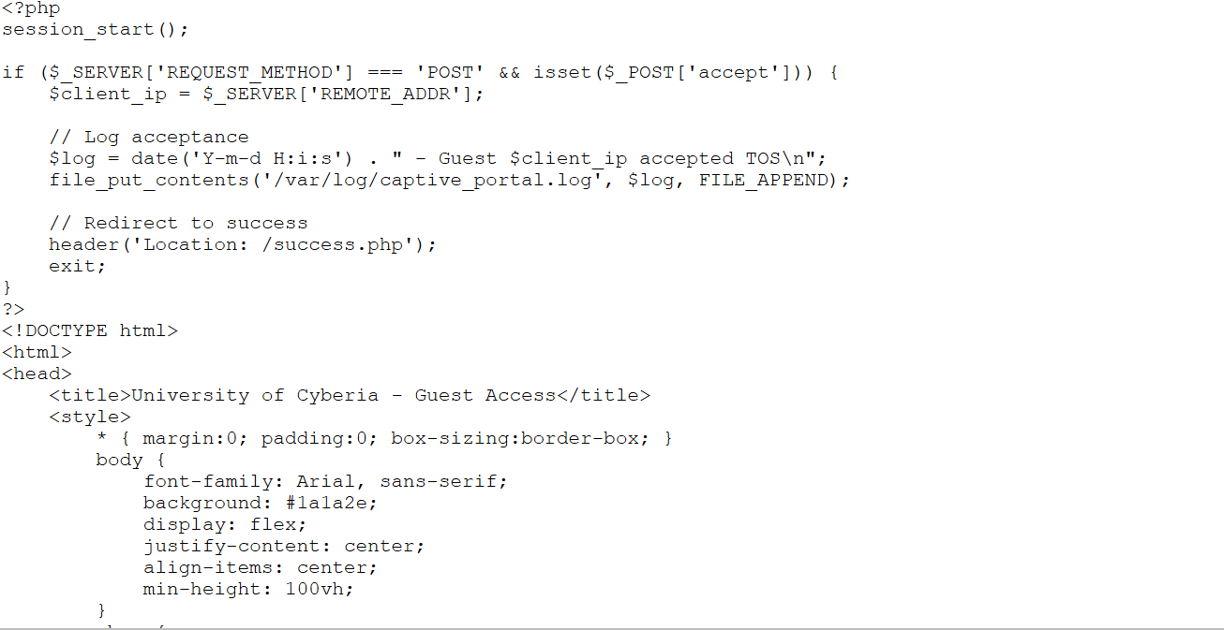
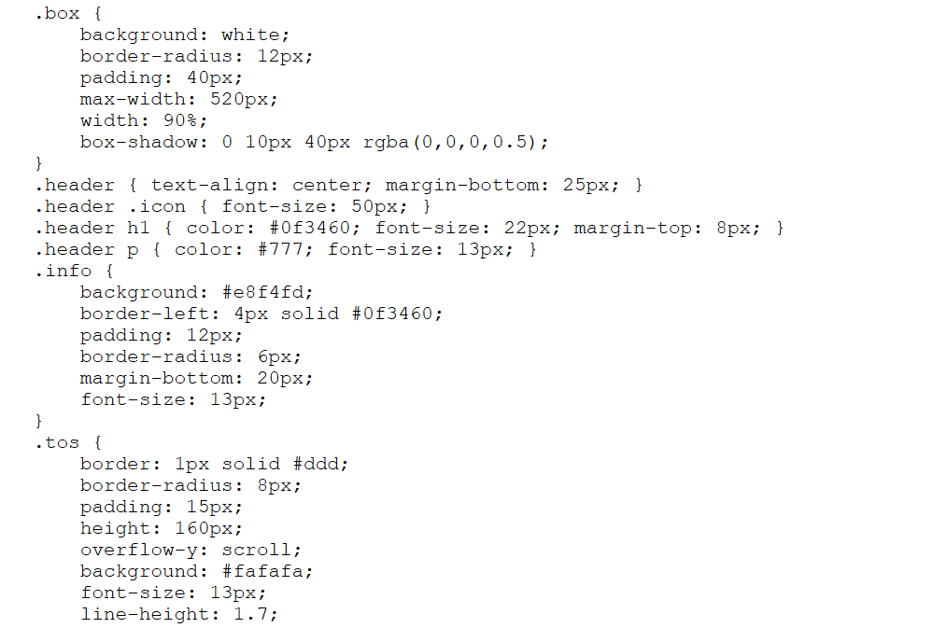

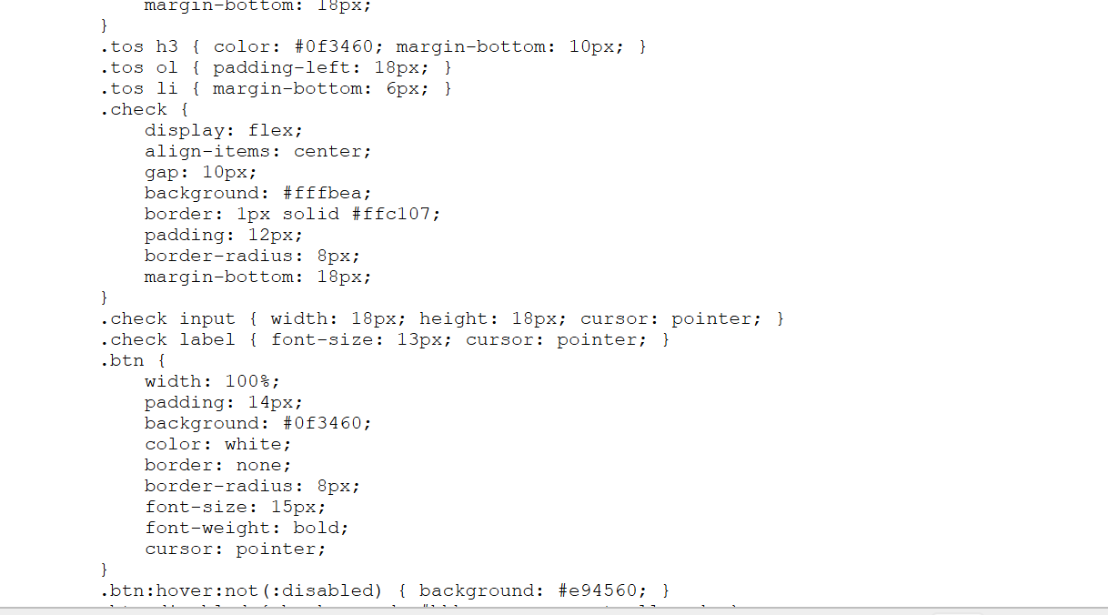
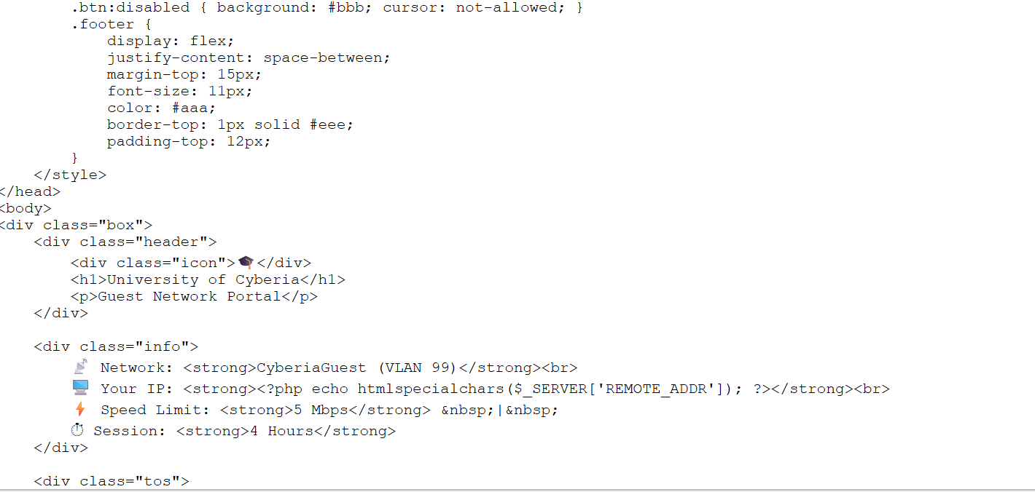
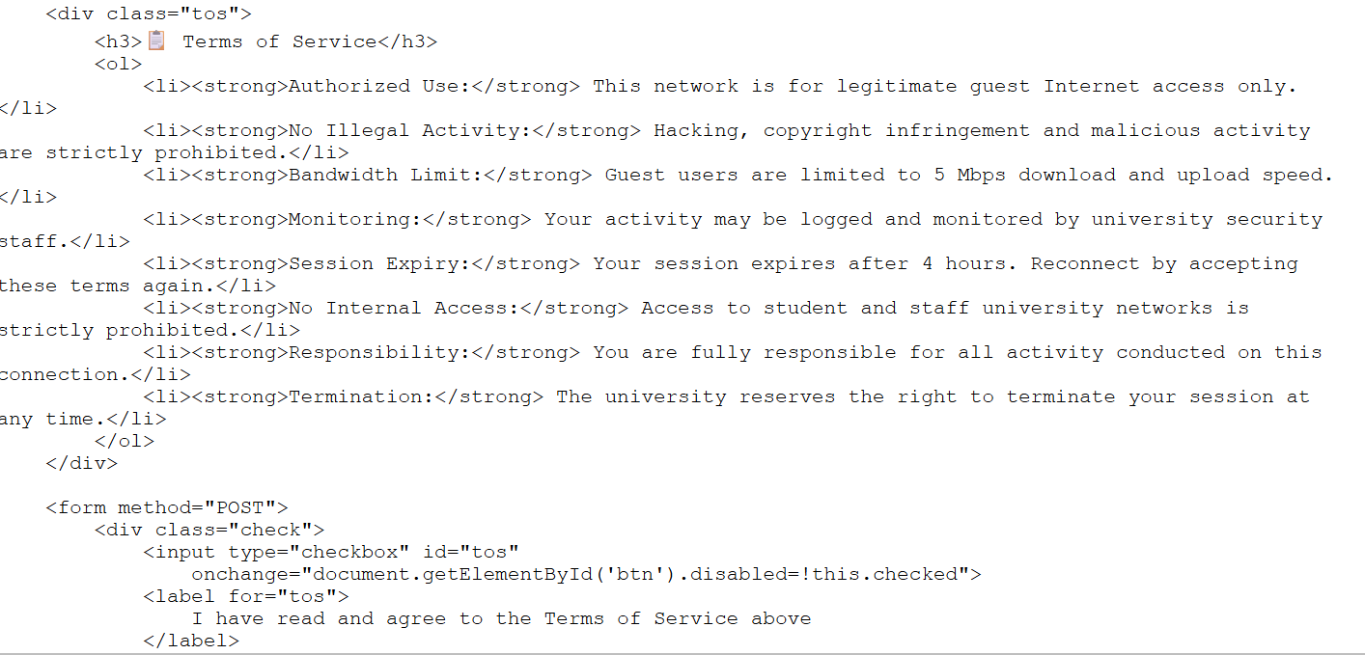
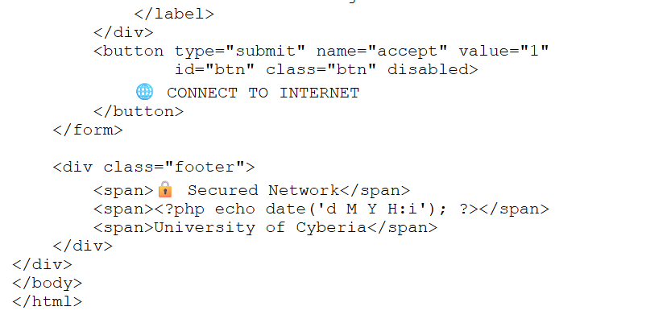

Session Authorization & Redirection:

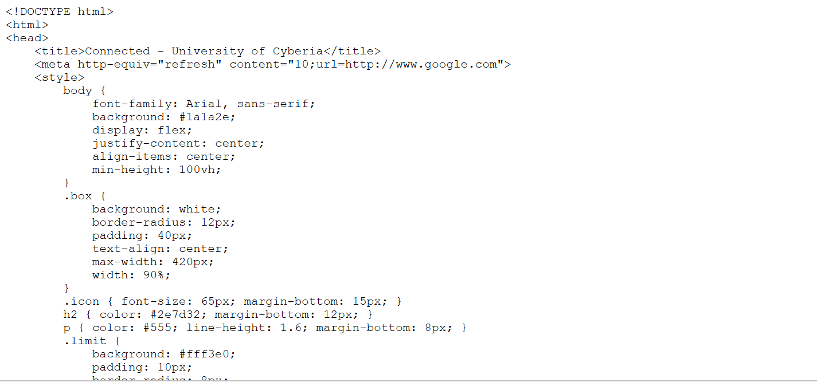
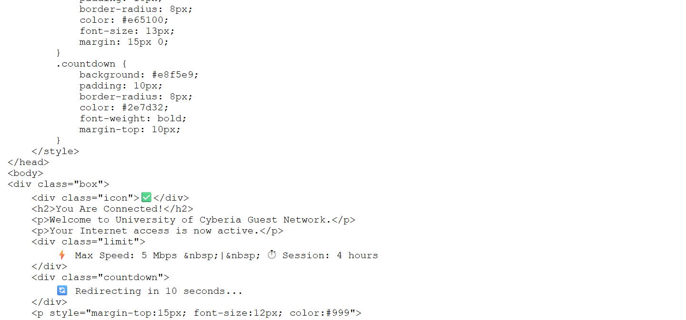
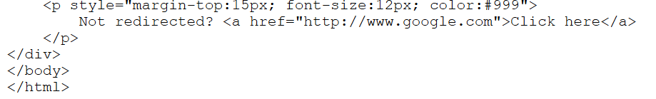
Core Components and Architecture:

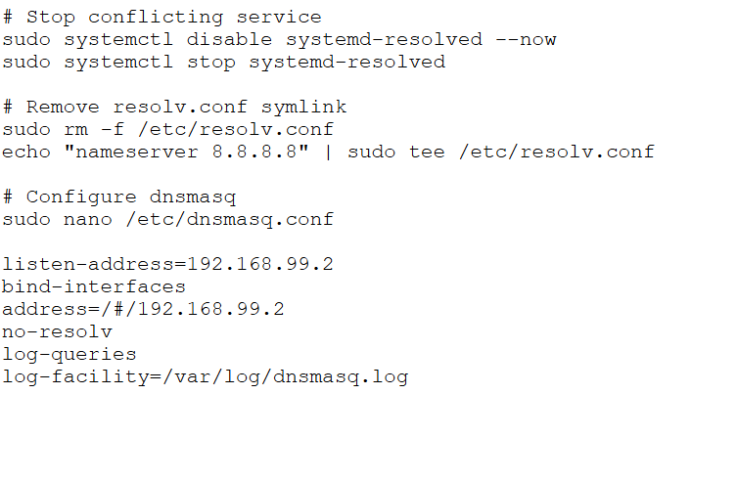
Conclusion:
In short, my main job as the Automation Lead was to handle guest internet access. I created the captive portal pages (captive_portal.php and success.php) and configured the DNS trap (dnsmasq).Now, when a guest connects to our campus network, they cannot use the internet until they accept the network rules. Once they click accept, the system saves their info, shows a success page, and redirects them to the internet after 10 seconds.Everything is working perfectly. This project was a great experience for me because I learned how coding and networks work together to make a system safe and automated.

